Walden Huntington 924 Transcription Project
Learning Objectives:
- To learn how to transcribe literary manuscripts from holograph (handwritten-by-the-original-author) sources
- To apply your basic knowledge of XML encoding
- To learn how to search the TEI Guidelines for elements and attributes and, deliberately making critical and creative choices, use those elements and attribute to create accurate, clear, illuminating markup of a digital edition
- To tell the story of a literary’s work’s genesis and to recognize the many other possible stories that might arise from the same documentary evidence.
- To explain these achievements of yours with accuracy and confidence, as you eventually may to potential and present employers.
- To develop confidence and flexibility in experimenting with unfamiliar digital tools, languages, and methods; getting to the point where you can say to an employer, “I can figure out how to do that.”
Instructions
- You are each assigned one page of one of the multiple manuscripts of Thoreau’s drafts of Walden, that contains material ultimately published in “Former Inhabitants and Winter Visitors.” Your job is to transcribe ONE passage of the page in XML, using TEI tags to show what Thoreau added, deleted, or changed, and when – in essence, how he wrote and revised that page. So, please start by downloading your facsimile – the photo of the manuscript page - and saving it locally. The URL will take you to a photograph of that page created by the Huntington Library in California, which possesses these parts of Thoreau’s manuscripts.
Editor | Passage about… | Facsimile
Amelia, Lily, Emily, Elizabeth | Zilpha | From Draft E. Vol. 5, p. 165.
 | Brister Freeman | From Draft F. Vol. 5, p. 166.
Kristin, Dani, Heather, Kira
Savannah, Kaitlyn, Anna | Zilpha | From Draft E. Vol. 5, p. 165.
Morgan, Alexis, Nate | “the site of these dwellings” (at the end of the page.) | From Draft F. Vol., 6, p. 140.
Tehya, Seth, Danielle | Demon Rum & Breed’s Hut | From Draft F. Vol. 6, p. 132.
Name not here? Let Dr. Nesvet know ASAP.

- What’s a passage?
  - 2-5 complete sentences, or one run-on sentence. One developed idea.
  - I’m happy to help you to determine how much of your page might be a passage.
  - Extra challenge: transcribe the complete page. (Extra credit available for this. Also great admiration.)
- Each page corresponds to a passage in Walden. You should look up the passage in either the Reader’s Walden or your Norton Edition: that will make it easier for you to transcribe it – and to see what revisions Thoreau made.
- Print your facsimile photo (one page). Get a pen. Give yourself 15 minutes. Trace over Thoreau’s handwriting. Try to read as you trace. Where he crosses something out, do that. Where he revises, trace the revision. It’s OK if you don’t understand most words or don’t get the order “right.” You’re doing this for the mindfulness of it, for the ritual. Make his hand yours. (Seriously, this is not new age woo woo. Don’t skip this step. That will make the next ones more difficult.
- Open the transcription template, in oXygen. Do not use Word, GoogleDocs, or any Google application: it will ruin your formatting. So will any application with autocorrect. Do not even write a draft or take notes with these tools. Here, for example, is the page that Dr. Nesvet transcribed:
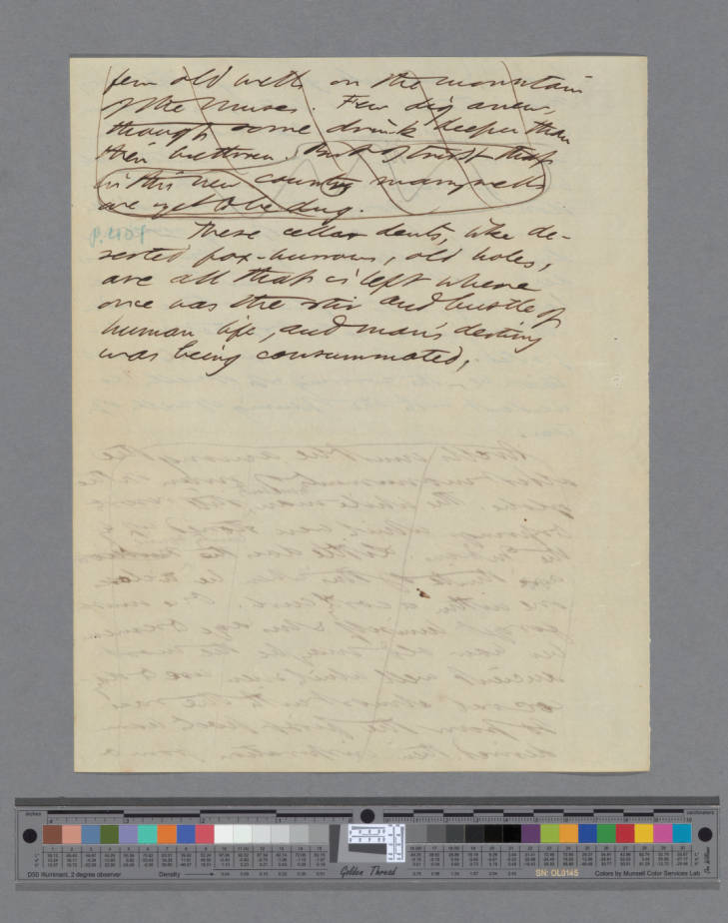
(You may enlarge this in Word)
https://cdm16003.contentdm.oclc.org/digital/collection/p16003coll16/id/1149

- In the menu at the top, go to “document” then “edit” then “toggle line wrap.” This will let you see the entirety of each line without it running off the page. You may use the same menu to enlarge the “font size.”

- Go to the TEI Header. Fill it in with your name as editor, etc. (See instructions in green comment tags.) There’s no wrong way to write this metadata. You decide how to make it clear. Don’t spend too much time on this part. Essential stuff: your name, volume number of the Huntington MS 924, page number of that volume you will transcribe, facsimile URL. See my sample transcription (below and on Canvas):

<?xml version="1.0" encoding="UTF-8"?><?xml-model href="http://www.tei-c.org/release/xml/tei/custom/schema/relaxng/tei_lite.rng" type="application/xml" schematypens="http://relaxng.org/ns/structure/1.0"?>
<TEI xmlns="http://www.tei-c.org/ns/1.0">
<teiHeader>
<fileDesc>
<titleStmt>
<title level="m"><hi rend="italic">Transcription of a Page from Huntington MS 924</hi></title>
<title level="a"><hi rend="italic">Walden Drafts</hi></title>
<author>Henry David Thoreau</author>
<editor>Rebecca Nesvet<!--your name here--></editor>
<respStmt>
<resp>Transcribed and Encoded By</resp>
<name>Rebecca Nesvet<!--your name here, again--></name>
</respStmt>
</titleStmt>
<publicationStmt>
<p>Not for public circulation.</p>
</publicationStmt>
<sourceDesc>
<p><bibl><author>Thoreau, Henry David</author> <title level="a">Walden</title>. <biblScope unit="no">Huntington MS 924</biblScope>
<biblScope unit="vol">6</biblScope> <biblScope unit="page">142</biblScope>
<date type="earliest" when="1853">1853</date>
<date type="latest" when="1854">1854</date><!--I chose to represent the approximate date this way, but the TEI Guidelines suggests a number of other equally valid formats.-->
<ref type="URL">https://cdm16003.contentdm.oclc.org/digital/collection/p16003coll16/id/1149</ref>
</bibl>
</p>
</sourceDesc>
</fileDesc>
<encodingDesc>
<p>Transcribed from HM 924 and encoded in XML in accordance with the TEI Guidelines.</p>
</encodingDesc>
<profileDesc>
<langUsage>
<language ident="en">English</language>
</langUsage>
</profileDesc>
<revisionDesc>
<list><item><date when="2017-11-26" resp="#rnes">26 Nov 2017</date>Encoding shell drafted.</item>
<item><date when="2020-08-30">30 August 2020</date>Filled in the header.</item>
<item><date when="2020-09-01">01 September 2020</date>Transcribed the text with markup to show revisions</item>
<item><date when="2020-09-02">02 September 2020</date>Corrected a mistake.</item>
</list> </revisionDesc></teiHeader>
- Keep your facsimile onscreen next to your oXygen window. You may magnify the photo, zooming in and out as you work.
- In oXygen, in the XML file (the template), in the BODY section, transcribe your passage as it appears in the facsimile (the page photograph). In most cases, there will be considerable differences from both the Norton edition and the Fluid Text Walden. This will take a long time and more than one pass. It’s best to get the words you can and put in something like XXX for the ones you can’t yet, then go back and fill in. And repeat.
- In XML in accordance with the TEI Guidelines, mark up your transcription. Yes: use TEI tags. Here are some common ones that I think you, all 18 of you collectively, will need to use to transcribe these pages. You can find more in the TEI Guidelines at www.tei-c.org

ELEMENTS
<add></add> (addition) contains letters, words, or phrases inserted in the source text by an author, scribe, or a previous annotator or corrector. More: https://tei-c.org/release/doc/tei-p5-doc/en/html/ref-add.html
<del></del> (deletion) contains a letter, word, or passage deleted, marked as deleted, or otherwise indicated as superfluous or spurious in the copy text by an author, scribe, or a previous annotator or corrector. More: https://tei-c.org/release/doc/tei-p5-doc/en/html/ref-del.html
<gap/> indicates a point where material has been omitted in a transcription, whether for editorial reasons described in the TEI header, as part of sampling practice, or because the material is illegible, invisible, or inaudible. More: https://tei-c.org/release/doc/tei-p5-doc/en/html/ref-gap.html
And if you have additions and deletions INSIDE other additions or deletions...
<addSpan></addSpan>(added span of text) marks the beginning of a longer sequence of text added by an author, scribe, annotator or corrector
<delSpan></delSpan>n (deleted span of text) marks the beginning of a longer sequence of text deleted, marked as deleted, or otherwise signaled as superfluous or spurious by an author, scribe, annotator, or corrector.
<handNote></handNote> Usually used as a note in a different handwriting from the main text

ATTRIBUTES
“rend” = rendering - how it's rendered/written. For instance:
For I hate this <del rend="strikethrough" hand="editor">my</del> body, which is so dear to me ... <handNote type="editor">D H Lawrence holograph</handNote>
Other possibilities:
<add rend="caret"/></add>
<add rend="wordballoon"></add>
... or even invented VALUES for kinds of renderings, such as this one from last year:
<del rend="hotdogstrikethrough"></del>
another attribute: PLACE:
As in: <add hand="#RG" place="margin">Norton</add>
Or: <add hand="#RG" place="upperleftcorner">Norton</add>
Here's how to add the attribute REASON to the element GAP:
Others <gap reason="holepunched" quantity="3" unit="cm"/> [3 holes punched, creating gaps in the text]
Or: I am sincerely your <gap reason="illegible" quantity="2" unit="word"/>Sydney Smith
TEI tags for other kinds of physical damage: https://tei-c.org/release/doc/tei-p5-doc/en/html/PH.html#PHDA

Always tag cross-outs, additions, squiggles, anything illegible, damage to the page, changes in ink color/handwriting… Try to show Thoreau’s writing process. Big questions for you to think about on your own and us all to discuss on Zoom:
- Just within this passage, what has Thoreau added, deleted, or changed? (How can you tell? From the handwriting: crossouts, carets, etc.)
- Are there other features of the manuscript we should observe, such as page numbers, holes, changes of ink, changes of handwriting…?
- Can you tell from changes in the appearance of the ink if he wrote the whole page at once or not? If someone else added anything later?
- What color is the ink? What might this color tell you about whether Thoreau wrote the whole page at once, or came back and corrected it, or what? (Hint: ink gets weaker as the pen runs on without re-dipping.) Any odd colored inks? What might that mean?

Here is 1. my facsimile (again) and 2. an extract from my transcription containing the entire <body/>:

(you may enlarge this in Word)
<text>
<body>
<div type="volume" n="6"><!--change to the correct volume number, which is in the facsimile's metadata-->
<div type="page" n="6"><!--change to the correct page number, which is in the facsimile's metadata-->
<p><del type="slashes">few old wells on the mountain of the Muses. Few dig anew, though some drink deeper than their brethren. <hi rend="circled">But I trust though in this new country many wells are yet to be dug.</hi></del></p>
<p><hi rend="blue pencil">p. 401</hi>These cellar dents, like deserted fox-burrows, old holdes, are all that is left where once was the stir and bustle of human life, and man's destiny was being consummated.
</p>
</div>
</div>
</body>
- In plain text – again, not in Word nor Google Docs, write a 600-800 word critical commentary explaining your process of transcription and encoding and what you learned from this process about the TEI (global Project, Community, and/or Guidelines), Thoreau and/or Walden, and yourself.
- Paste your critical commentary onto the <back> section of your transcription (the XML file).
- Submit your completed XML file – transcription with commentary – to the Canvas dropbox.
Your work will be shared with the national Digital Thoreau team. It will help us to devise guidelines, best practice policy, and tutorials for imminent future transcription of the Huntington 924 manuscript.

